[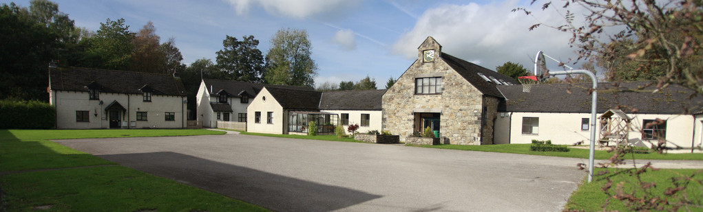](http://www.google.co.uk/url?sa=i&rct=j&q=&esrc=s&source=images&cd=&cad=rja&uact=8&ved=0ahUKEwjB-r_ZiLDPAhVCfhoKHXLECrcQjRwIBw&url=http://www.acornschools.co.uk/provisions/underleygardenschool/adult-care/&psig=AFQjCNEAGzbNH1V6-EImw5P8FVO_nxwFRg&ust=1475080994859446)

School Prospectus

2024-2025

Mission Statement

Underley Garden adopts a holistic, person-centered approach to the development of children and young people and endeavors to ensure that they achieve the best possible outcomes. We offer a comprehensive portfolio of education, therapy and care to meet the individual requirements of children and young people with complex special educational needs.



Introduction

The Head of Service, Headteacher, staff, children and young people would like to welcome you to the school at Underley Garden. If you have not yet visited us, please feel more than welcome to do so. Simply telephone the school to make an appointment. Our number is 015242 71569.

This prospectus provides general information about the school. If you require more detailed information or have any questions, please do not hesitate to contact us by telephone. We are a school dedicated to working closely with parents/carers and Local Authorities to provide for the individual needs of our children and young people and we therefore welcome contact with anyone who has an interest in the school.

You can also visit the school website for further information a[t **w**](http://www.underleygarden.org/)**w**[**w.underleygarden.org**](http://www.underleygarden.org/)

Underley Garden is part of Options Autism.

Contact details.

**Head of Service:** David Glaves

**Headteacher:** April Boyd

**Address:** Underley Garden, Kirkby Lonsdale, Carnforth, LA6 2DZ

**Telephone Number:** 015242 71569

**Email:** [info@underleygarden.org](mailto:info@underleygarden.org)

**Registered Number:** 03834802

**Chief Executive:** David Leatherbarrow

**Chair of Governors:** Ann Henderson

**Registered Office:** Turnpike Gate House, Alcester Heath, Alcester, Warkwickshire B49 5JG

**Telephone Number**: 08442 487187

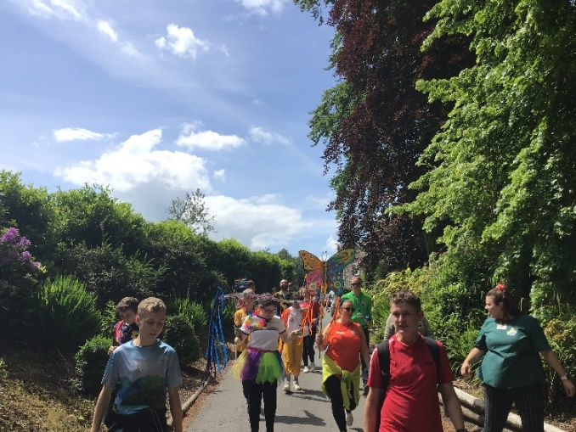

The School Aims

Underley Garden adopts a holistic, person-centered approach to support the development of our children and young people, taking into account current theories and effective evidenced methods of teaching and learning.

All of our children and young people have significant barriers to learning due to their complex learning difficulties and disabilities in the area of autism spectrum disorder, learning difficulties, associated social, emotional and mental health conditions and medical and health issues. Our role is to help our children and young people learn coping strategies to support them in their everyday life.

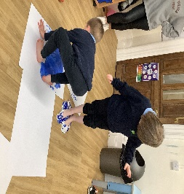

Admissions

The school, which is co-educational, provides places for up to 104 children and young people aged 5 to 19.

The school is non-denominational and has a secular ethos but respects the cultural needs and religious beliefs of all of our community.

We are able to offer places to children and young people who meet the criteria set out on the following page. We currently receive referrals from Local Authorities (education/social care), health authorities (Primary Care Trust/CAMHS), parents/carers and other independent professionals/bodies.

Admission Criteria

* Children and young people will be aged between 5 and 18 years.
* All children and young people will have an EHCP/equivalent or are under assessment (education, care or health)
* Children and young people whose needs stem from complex learning difficulties and disabilities; including autism spectrum disorder, learning difficulties, associated social, emotional and mental health conditions and medical and health issues.
* We only admit children and young people whose places are funded by a UK authority.

Admissions Process

We welcome initial telephone or email enquiries. In order to begin the referral process, we require a written request with relevant accompanying paper advice. Once this has been received the referral process will begin whereby, we ensure we have all the relevant information, conduct initial assessments of papers which included input from our Health and Therapy team and invite parents/carers and the child or young person to visit the school. Our staff will then visit the child or young person in order to meet them and assess whether we can meet their educational needs. For more information regarding the referral process at Underley Garden, please contact us.

Education Health Care Plan (EHCP)

Everyone at Underley Garden is committed to providing the environment and opportunities to enable all children and young people with special educational needs to be included, fully, in all aspects of school life.

In order to meet the special educational needs of our children and young people we will develop, implement and monitor appropriate programs for children and young people linked to their EHCP (or equivalent) outcomes. We use a variety of teaching styles and cater for different learning styles to allow children and young people to access the curriculum and resources effectively. Our health and therapy team work closely together and in collaboration with school, parents/carers and other professionals to provide a holistic approach to interventions. Therapy targets are integrated into the school day and embedded into their curriculums. We endeavor to involve and inform the parents/carers of children and young people so that we can work together and ensure the best outcomes for all.

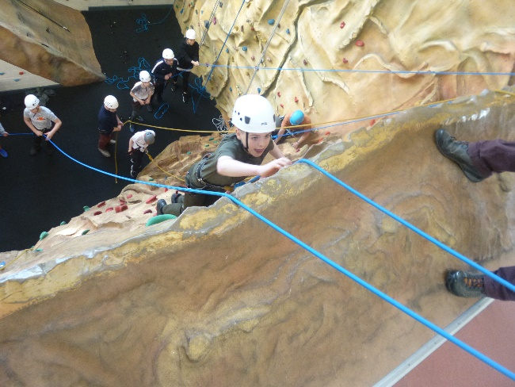

Curriculum

At Underley Garden we ensure access to the curriculum areas that are listed in the Independent School Standards (2014). In accordance with this we endeavor to provide a curriculum that meets the needs of each young person based on the terms of the Education Health Care plans (EHCP) or equivalent.

All children and young people receive full-time supervised education, in which they experience a curriculum that includes a range of linguistic, mathematical, scientific, technological, human and social, physical, aesthetic and creative aspects appropriate to their age, ability and aptitude. These experiences are taught dependent on the needs and abilities of the children and young people in a variety of ways. The overriding aim of the curriculum is to achieve the best possible outcomes for children and young people in terms of personalised learning, independence, personal growth and development. Preparing them as much as possible for the next stage of life after Underlay Garden.

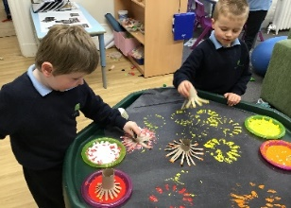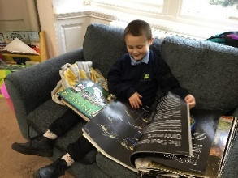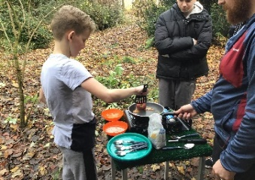

Teaching and Learning

Through successful teaching and learning, the children and young people will become lifelong learners and achieve the highest level of independence.

We recognise that all children and young people have special skills, abilities and aptitude and have an entitlement to access a broad, balanced, challenging and relevant curriculum. As well as this, every child and young person is entitled to experience a variety of teaching and learning styles, thus enabling them to achieve their full potential. As there are many teaching & learning opportunities outside the formal curriculum, we strive to provide children and young people with optimum conditions for achievement and development in all situations.

At Underley Garden we aim todevelop confident and enquiring learners who are able to make informed choices. We underpin teaching and learning by a variety of therapeutic approach and strategies. Build on natural curiosity and enthusiasm for learning and promote self-esteem and self-confidence.

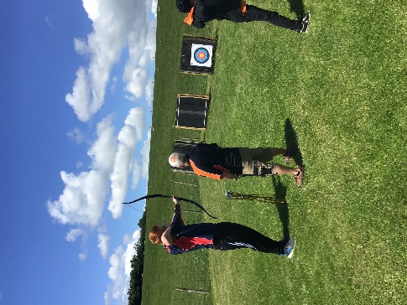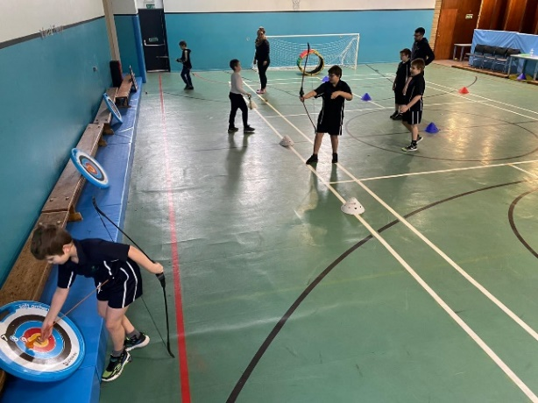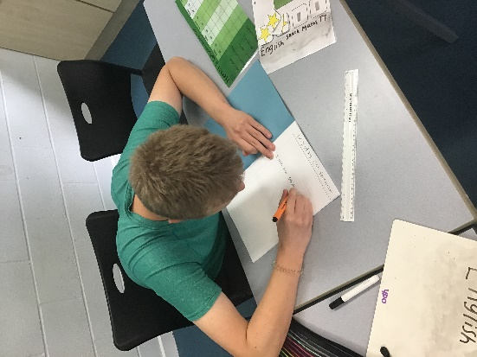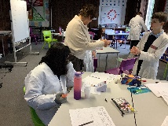

Pathways:

We have segmented our curriculum into Pathways to encompass all learning journeys for our young people.

It is key to note that every child’s learning journey is different and as a school we have varied expectations of progress dependent on that child’s needs. Our young people will be assessed when they are referred to us and using a multi-disciplinary approach, we map out their curriculum using a pathway that best suits their needs at the time. This is reviewed every term and the pathways are made fluid so that a young person can move between pathways if needed.

Curriculum Pathway Information:

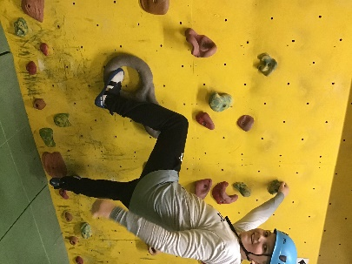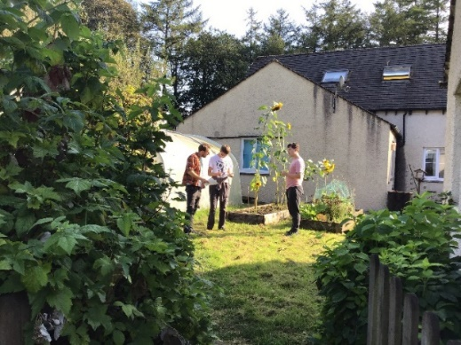

Outdoor Education: Majority of the children and young people access Outdoor Education throughout the year. The only children who do not access this is those wishing focus on accreditation.

Assessment, Recording & Reporting

Assessment, recording and reporting of progress is essential to ensure that all children and young people make the best possible progress through studying an appropriately differentiated curriculum. Assessment is central to informed curriculum planning for each child and young person and to ensure that teaching and learning approaches build on children and young people’s strengths and abilities and reduce any barriers to learning that they may experience.

Underley Garden actively seeks to meet all statutory obligations with regard to assessment, recording and reporting. In addition, a variety of additional tools are used to ensure that the needs of individual children are appropriately understood and planned for. As well as formal assessment; Underley Garden takes in to account the individual learning needs of each child and young person to ensure their curriculum meets their learning needs.

The school provides termly reports to parents/carers that detail progress and achievement. An annual review report is also produced and sent to parents/carers and relevant Local Authority professionals, which form the basis of the Statutory Annual Review.

Swimming: Majority of the children and young people access swimming sessions throughout the year. We swim at Lune Valley Swimming Pool at Hornby where we privately book the pool and a swimming instructor.

Post 16 Provision

Post 16 provision offered at Underley combines our in-depth knowledge of our pupils needs with a curriculum which supports a successful long-term transition into adulthood, focussed on developing skills for work and employment and living successfully within a community.

Within Post 16 our learners will access tuition and scaffolding around communication and social skills, personal organisation, transport and independent travel, timekeeping and attendance, Budgeting, Independent living skills, continued Careers advice/guidance, British Values and rights and responsibilities within society, whilst continuing to embed and develop maths and English knowledge. Levels of independence would gradually develop, and skills consolidated across all settings. Learners will develop these skills following teaching and learning of Open Award awards, specifically focussing on skills for further learning and employment and independent living, together with our career’s curriculum, gaining a Personal Development and employability qualification from the Princess Trust.

The complexity of SEND present within the Underley Garden School cohort may not immediately be met within mainstream FE settings via the year 11 to 12 pathway. Although our students may have appropriate academic ability, their needs in relation ASD, Communication and Interaction, Sensory, Physical and Developmental Delay, can lead post 16 mainstream providers unable to meet their holistic needs.

Underley Garden works closely with local FE settings to positively support next steps into mainstream provisions, should this be a pathway of choice. This supportive platform enables their next educational step with increased levels of independence.

Spiritual, Moral, Social and Cultural (SMSC)

Underley Garden aims to provide an environment where children and young peoples’ Spiritual, Moral, Social and Cultural (SMSC) development can flourish. We will provide opportunities for all children and young people to learn and achieve and promote their SMSC development to prepare them fully for the opportunities, responsibilities and experiences of adult life.

**British Values**

Underley Garden will actively promote the fundamental British values of democracy, the rule of law, individual liberty, and mutual respect and tolerance of those with different faiths and beliefs. Staff will challenge opinions or behaviours that are contrary to fundamental British values.

Personal, Social, Health and Economic education (PSHE)

Learning PSHE helps children and young people develop as an individual in a wider society.

The PSHE curriculum is based on three ‘core themes’; Health and Wellbeing, Relationships and Living in the Wider World. These include the teaching of.

* Alcohol, smoking and drugs.
* Personal health
* Bullying
* Citizenship, democracy and human rights
* Careers and the world of work
* Personal finance
* Family
* Relationship and sex education
* E-safety

Children and Young People who have English as an Additional Language (EAL)

Underley Garden welcomes and values the cultural, linguistic and educational experiences that children and young people with EAL bring to the school. We implement school wide strategies to ensure that EAL children and young people are supported in accessing the curriculum.

Our aim is to help EAL children and young people to become confident and fluent in English, where possible, to be able to fulfil their academic potential.

Underley Garden works with parents and carers to ensure we have a good understanding of the needs, interest and preferences of children and young people to motivate them and help them learn and progress. We provide the information that all parents are entitled to, however where parents do not have sufficient command of spoken or written English, seek appropriate help to facilitate this.

Rewards and Consequences

Rewards and Consequences form part of the School’s Behaviour Policy practices and procedures. Rewards should reinforce positive behaviour or recognise a good achievement across all learning environments.

Additional Information:

Careers Education and Information, Advice and Guidance

Underley Garden ensures careers is embedded throughout the curriculum for all children and young people.

At Underley Garden, the Career Development Institute (CDI) framework is the foundation of our Careers curriculum up to and including Key stage 3. At Key stage 4 and above The Princes Trust Personal Development and employability Qualification supports the delivery of careers education curriculum. We also follow the Gatsby Benchmarks as part of the DfE Careers Strategy.

When a child or young person reaches Year 7, they will access 1:1 meeting with an internal Careers Advisor and from year 9 the school establishes a transition plan which involves; the young person, parents, teachers and either our internal Careers Advisor or a Personal Adviser from Inspira. They then look at possible options for when they leave Underley Garden and also any actions that need occur to prepare them. The school’s Careers Adviser meets regularly with all children and young people on an individual basis to discuss their needs and preferences and to give advice and support.

At Underley Garden, we work alongside further education providers to ensure the young people are fully supported into their next chapters.

Bullying and Harassment Statement

Bullying behaviour is not accepted in school and is never ignored.

Bullying is behaviour, which is deliberately hurtful and frightening and can include both physical and verbal forms. If bullying is suspected or reported it is investigated immediately. It is dealt with appropriately and followed up later to ensure that it has not resumed. Underley Garden does not tolerate bullying behaviours.

Work Experience

Work experience is offered in different ways with the aim of providing children and young people with opportunities that enable them to develop skills at an appropriate level and pace.

Work experience aims to give children and young people the opportunities to gain an insight into a career or chosen occupation, to experience day to day aspects of employment,  learn beyond the confines of the organised curriculum, understand their own strengths and areas for development, build confidence and independence, connect their learning with working lives, work as part of a team, develop skills of self-evaluation, demonstrate organisational skills and understand the importance of matters relating to Health and Safety. We explore opportunities both on and off site, making community links and accessing work-related learning through a range of visits/workshops by external visitors ensuring the young people have access to mandatory provider access and work experience.

Health and Therapy Team

A Professional Team of on –site and consultant therapists and medical professionals. Our Health & Therapy team at Underley comprises of Educational Psychologists, Psychotherapist, Child and Adolescent Psychiatrist, Speech and Language Therapists, Learning Disability Nurses and Occupational Therapists.

This team work closely together and in collaboration with school and care staff, parents and other professionals to provide a holistic approach to interventions.

Therapy targets are integrated into the school day and into the home and embedded into their learning curriculums to ensure the best possible outcomes for our children and young people.

Good Behaviour and Discipline

At Underley Garden we aim to promote positive social, emotional and behavioural change in our children and young people through a supportive and consistent approach across education and care based on the needs of our children and young people.

Underley Garden support vulnerable children and young people who experience significant barriers to learning due to severe and complex learning difficulties and disabilities, autistic spectrum condition, associated medical and health needs and mental health needs and associated challenging behaviours.

The organisation uses, CPI: Safety Intervention as a preferred method of Restricted Physical Intervention (RPI) as approved by BILD and recognised by the restraint reduction network (RRN). The use of RPI is always used as a last resort (unless otherwise stated in a My Plan) where other means of de-escalation are unsuccessful and where the degree of risk has been appropriately assessed.

The definition of RPI for holding as stated by CPI: SI is: *‘The use of a physical intervention to restrict a person’s liberty of movement’*.

As a company we adopt the approach and follow the guidance from the HM Government: Reducing the Need for Restraint and Restrictive Intervention Paper; Published: 27 June 2019.

Pastoral Support

The school endeavors to provide support for children and young people to enable them to achieve academically, socially and personally.

Systems of support include the Form Tutor, Teaching Assistants and members of the Health and Therapy team who offer guidance to ensure children and young people are happy, engaged and looked after within school. We also ensure parents and carers feel involved in their child or young person’s school life and share and ideas and strategies which may support their home life.

Form tutors maintain regular contact with parents and carers through daily home/school diaries, telephone calls and emails. There are also termly school reports sent home along with annual reviews of the Education, Health, Care plan where the professionals working with a child or young person are invited to discuss their progress.

Progress Meetings monitor children and young people’s development, and review and revise targets.

Equal opportunities and the values of the school

The school is committed to a policy of equal opportunities for all children and young people, staff and others who come into contact with the school regardless of race, colour, gender, sexual orientation, religion or disability. Everyone visiting, working or learning in the school should feel welcome, secure and confident at all times. They should feel valued and able to participate fully in the life of the school.

The school recognises and integrates the principles within The Equality and Diversity Act 2010 in its practices and procedures.

Safeguarding and Child Protection

Underley Garden takes seriously its responsibilities to protect and safeguard the interests of all children and young people. The school Safeguarding Policy, which includes Child protection, is available from the school website [www.underleygarden.org](http://www.underleygarden.org/)

Homework

Homework is sent home weekly and differs dependent on key stage and ability.

Parent/carers are asked to support the children and young people with their homework but also allow opportunities to progress their learning through opportunities to read and practise independent and communication skills at home.

School Uniform

Uniform consists of navy school jumpers (2 of which are provided by school at the beginning of each school year), white or pale blue polo shirts, black or grey trousers/skirt and black shoes. Black fashion trainers are not part of the school uniform and parents are asked to refrain from buying these as school shoes. Young people attending college (Post-16) do not have a full uniform however are asked to wear a Post-16 hoodie and appropriate clothing for college. PE kits are provided by the school however consist of navy and white polo shirt, shorts, tracksuit top and bottoms. Children and young people will need to bring trainers/pumps for their PE lessons. Some classes attend weekly swimming lessons and so should attend school with swimming costume/shorts, towel and goggles on the relevant day.

It is helpful if all clothing coming into school is labelled with names to prevent property from becoming lost.

Transport

Transport is provided by local authorities for all day children and young people. They are accompanied by escorts in the vehicle and may share transport with other children and young people from the school. Underley Garden has no involvement in the transport process and all contact should be made to the Local Authority regarding any matters concerning this.

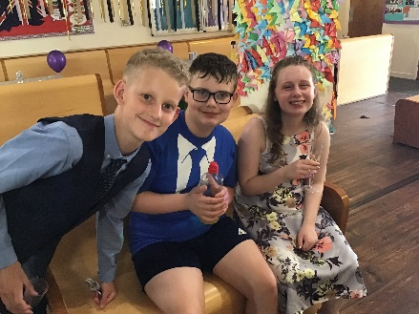

School Day

The school day begins at 9.00am and finishes at 3.15pm.

All children and young people have a morning break at 11am and have a lunch break at 12.00pm.

Meals are prepared and provided by school and we endeavor to provide healthy, balanced meals with all dietary requirements being catered for. If a packed lunch is preferred, we ask parents/carers to ensure the packed lunch is healthy and balanced and fizzy drinks, sweets and chocolate items are not included.

Complaints

If any parent/carer or other person wishes to make a complaint, they should contact the school either by telephone or letter and the complaint will be investigated and responded to within the time specified in the complaints policy. Copies of the school’s complaints procedures are available on request from the school office.

Exclusion

The decision to exclude a child either for a fixed term or on a permanent basis is serious and will normally only be the final step in a range of strategies that have been unsuccessful.

Our preference is always to work with parents/carers and the placing authorities where a placement is experiencing severe difficulties.

**Senior Leadership Team**

David Glaves- Head of Service

April Boyd- Headteacher *(BA Hons in Primary Education with QTS)*

Nicola Harper (BA Hons in Primary Education with QTS)

Jo Savage-Deputy Headteacher (PGCE, QTLS, SENCo Award)

Sharon Keating- Assistant Headteacher & SENCo; *Inclusion*

Louise Kennon- Assistant Headteacher; *Curriculum*

Rochelle Sowden- Assistant Head; *Destinations*

Jessica Wilson- *Behaviour and Attitudes Lead*

Chris Kirkbride – Head of Care: *Children’s Home*

Lucas Finch –Registered Manager - *Children’s Home*

Melanie Pierce- Care Manager

**Health & Therapy Team**

Jennifer Heath – Locality Lead, Occupational Therapist, Sensory Integration Practitioner

Suzie High – Occupational Therapist, Sensory Integration Practitioner

Catherine Niblock –Occupational Therapist

Stacie Sharp - Speech and Language Therapist

Gill Denby – Speech and Language Therapist

Elizabeth Osborne – Speech and Language Therapist

Christopher Corban – Therapy Assistant

Zoe Levine-Wright - Registered Learning Disability Nurse

Gillian Duckett – Health Care Assistant

Claire Cave – Health Care Assistant

**Teachers & School Staff**

22 qualified teachers (*inc. SLT)*

5 unqualified teachers

3 cover supervisors

60 Teaching Assistants (Level 3 and Level 2)

**Administration, Domestics & Maintenance**

We have 20 members of staff providing support in administration, maintenance and ancillary.