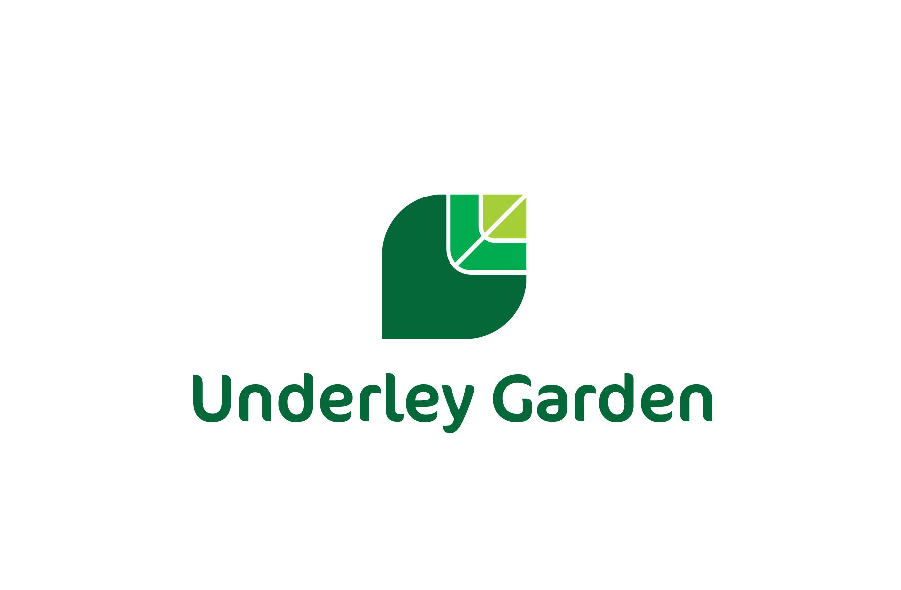

Complaints Policy

|  |  |
| --- | --- |
| **Reviewed:** | June 2024 |
| **To be reviewed:** | June 2025 |

|  |
| --- |
| COMPLAINTS PROCEDURES |
| This complaints procedure, as required by law in the Independent School Standards and Children’s Home Regulations, and the number of complaints registered under the formal procedure during the preceding school year will be made available on the school’s website.  The difference between a concern and a complaint  A ‘concern’ may be defined as ‘an expression of worry or doubt over an issue considered to be important for which reassurances are sought’.  A complaint may be generally defined as ‘an expression of dissatisfaction however made, about actions taken or a lack of action’.  It is in everyone’s interest that complaints are resolved at the earliest possible stage. Many issues can be resolved informally (Stage 1), without the need to invoke formal procedures (Stages 2 & 3).  We take all concerns seriously and will make every effort to resolve any matter raised, as quickly as possible.  Who can make a complaint?  Any person, including members of the general public, may make a complaint to Underley Garden about any provision of facilities or services provided. This includes parents/carers of children no longer at the school. Unless complaints are dealt with under separate statutory procedures (such as exclusions or admissions) we will use this complaints procedure.  Complaints from Parents/Carers  It is expected that complaints are made as soon as possible after an incident arises (although three months is generally considered to be an acceptable time frame in which to lodge a complaint). The procedures below will be followed in the event of a complaint being made by parents or carers against Underley Garden (complaints are not limited to parents or carers of children that are registered at Underley Garden).  Informal Complaint (Stage 1)  If parents or carers have a complaint against the school/children’s home they may initially wish to contact the organisation informally either by telephone, in writing or in person. The organisation will ask the complainant what they think might resolve the issue. Underley Garden will consider and resolve as quickly, and efficiently as possible the complaint and will respond with the outcome within *10 days*, (where further investigations are necessary that will exceed this time period, new time limits will be communicated with an explanation for the delay). If the issue remains unresolved, the next step is to make a formal complaint.  Complainants should not approach individual governors to raise concerns or complaints. They have no power to act on an individual basis and it may also prevent them from considering complaints at Stage 2 of the procedure.  Formal Complaint (Stage 2)   1. If parents or carers are not satisfied with the response at Stage 1 they should write formally to the complaints officer; Headteacher, April Boyd (education) or Head of Care, Chris Kirkbride (children’s home) Underley Garden, Kirkby Lonsdale, Carnforth, Lancs, LA6 2DZ. The complaints officer will investigate the complaint further and respond in writing within 10 days (where further investigations are necessary that will exceed this time period, new time limits will be communicated with an explanation for the delay). If the complaint is against the Headteacher or Head of Care, the complaint should be addressed to the School’s Chair of Governors, also known as the Regional Director, Ann Henderson, Atria, Spa Road, Bolton BL1 4AG. The School’s Chair of Governors (Regional Director) will investigate and respond within 20 days.   Formal Complaint (Stage 3)   1. If the complainant is still not satisfied with the response at Stage 2 they should inform the organisations Chair of Governors (Regional Director) who will arrange a panel to hear the complaint. 2. The panel will comprise three people, not directly involved in the matters detailed in the complaint. At least one member of the panel will be independent of the running and management of the school/children’s home (The member should be outside the organisation’s workforce, and not a member of governing body/proprietorial body, but also should not be otherwise involved with the management of Underley Garden). 3. The date of the panel meeting will take into account the availability of the complainant as well as the school/children’s home and will take place within 30 days. If the complainant rejects the offer of three proposed dates, without good reason, the panel will decide when to hold the meeting. It will proceed in the complainant’s absence on the basis of written submissions from both parties. 4. The complainant will be invited to bring with them another person or persons to support them at the panel hearing if they wish. (The panel hearing does not confer a right on a parent to have a legal representative to make representations on their behalf at the hearing). 5. The panel will hear the complaint and will hear the outcome of the organisation’s investigations and its response to these. The panel will then make findings and recommendations which will be communicated in writing within 10 days of the conclusion of the hearing to the Proprietor, Regional Director, the Head of Service, the Headteacher/Head of care, the complainant and, where appropriate, the person complained about. 6. If a complainant does not exercise the right to attend a panel hearing, the panel will meet in line with this policy. The organisation’s arrangements for the panel hearing will be reasonable in order to facilitate the complainant exercising the right of attendance. 7. A written record of all complaints and their resolution, whether they proceeded to a panel hearing or not, will be kept on the premises by the Head of Service/Headteacher/Head of care and made available to the Proprietor and Ofsted inspectors on request. The organisation will record the progress of the complaint and the final outcome. These records and any correspondence relating to a complaint will remain confidential, except where the Secretary of State or a body conducting an inspection under section 163 of the Education Act 2002 requests access to the records. 8. The number of complaints registered under the formal procedure during the preceding year will be published on the website.   Complaints from Pupils  The procedures below will be followed in the event of a pupil making a complaint against a member of staff, a fellow pupil or any other person or situation either in school/children’s home or outside.  Pupils may wish to talk to an adult they trust about a situation relating to school/children’s home or to a situation outside.  Pupils are reminded that, although they may speak to any member of staff, there may be occasions where information will have to be referred to other agencies such as Children’s Services.  Within school/children’s home, pupils may talk to any member of staff.  A pupil may merely need a trusted adult to talk a situation through with and may not be making a formal complaint. However, all actual complaints made by pupils will be recorded by the member of staff in the Complaints Log. The organisations response to the complaint will also be recorded. If the complaint is serious the pupil’s parents/carers will be informed of both the complaint and the outcome. Some complaints will be referred to other agencies or to the Local Authority. If necessary, a meeting will be called to discuss the issues further.  A pupil may ask to speak to an adult from an outside agency. The organisation will, wherever possible, put the pupil in contact with a representative of the appropriate agency. The referral will be noted in the pupil’s file.  If the complaint is an allegation against a member of staff then the organisations safeguarding policy must be followed in addition to recording the complaint. Failure to follow this process may result in disciplinary action. |
| Unreasonable Complaints  Underley Garden is committed to dealing with all complaints fairly and impartially, and to providing a high quality service to those who complain. We will not normally limit the contact complainants have with the organisation. However, we do not expect our staff to tolerate unacceptable behaviour and will take action to protect staff from that behaviour, including that which is abusive, offensive or threatening.  The organisation defines unreasonable complainants as ‘those who, because of the frequency or nature of their contacts with the school, hinder our consideration of their or other people’s complaints’.  A complaint may be regarded as unreasonable when the person making the complaint:   * refuses to articulate their complaint or specify the grounds of a complaint or the outcomes sought by raising the complaint, despite offers of assistance; * refuses to co-operate with the complaints investigation process while still wishing their complaint to be resolved; * refuses to accept that certain issues are not within the scope of a complaints procedure; * insists on the complaint being dealt with in ways which are incompatible with the adopted complaints procedure or with good practice; * introduces trivial or irrelevant information which the complainant expects to be taken into account and commented on, or raises large numbers of detailed but unimportant questions, and insists they are fully answered, often immediately and to their own timescales; * makes unjustified complaints about staff who are trying to deal with the issues, and seeks to have them replaced; * changes the basis of the complaint as the investigation proceeds; * repeatedly makes the same complaint (despite previous investigations or responses concluding that the complaint is groundless or has been addressed); * refuses to accept the findings of the investigation into that complaint where the school’s complaint procedure has been fully and properly implemented and completed including referral to the Department for Education; * seeks an unrealistic outcome; * makes excessive demands on school time by frequent, lengthy, complicated and stressful contact with staff regarding the complaint in person, in writing, by email and by telephone while the complaint is being dealt with.   A complaint may also be considered unreasonable if the person making the complaint does so either face-to-face, by telephone or in writing/electronically:   * maliciously; * aggressively; * using threats, intimidation or violence; * using abusive, offensive or discriminatory language; * knowing it to be false; * using falsified information; * publishing unacceptable information in a variety of media such as in social media websites and newspapers.   Complainants should limit the numbers of communications with an organisation while a complaint is being progressed. It is not helpful if repeated correspondence is sent (either by letter, phone, email or text) as it could delay the outcome being reached.  Whenever possible, the Headteacher/Head of care or Regional Director will discuss any concerns with the complainant informally before applying an ‘unreasonable’ marking.  If the behaviour continues the Headteacher/Head of care will write to the complainant explaining that their behaviour is unreasonable, asking them to change it. For complainants who excessively contact the organisation causing a significant level of disruption, we may specify methods of communication and limit the number of contacts in a communication plan. This will usually be reviewed after 6 months.  In response to any serious incident of aggression or violence, the concerns and actions taken will be put in writing immediately and the police informed. This may include banning an individual from the premises. |



**Underley Garden Complaint Form**

**APPENDIX 1**

Please complete and return to April Boyd, Chris Kirkbride or David Glaves who will acknowledge receipt and explain what action will be taken.

|  |  |  |  |  |
| --- | --- | --- | --- | --- |
| **Your Name:** |  | | **Date:** |  |
| **Young Person’s Name:** |  | | | |
| **Your Relationship to young person:** | | | | |
| **Your preferred contact details:** | | | | |
| **Please give details of your complaint (attach a separate sheet if necessary):** | | | | |
| **What action, if any, have you already taken to try and resolve your complaint.** | | | | |
| **What actions do you feel might resolve the problem at this stage?** | | | | |
| **Are you attaching any paperwork? If so, please give details.** | | | | |
| **Signature:** | |  | **Date:** |  |

**For office use only:**

Complaint resolved: Yes / No Date:

Complaint referred to: Date:

Date acknowledgement sent:



**APPENDIX 2**

**Complaints Procedure for Young People**

If you are not happy with what we have said to you, how we have treated you or the service you have received then tell us about it.

**How do I make a complaint?**

A complaint can be made by anyone, either in person or someone can act on your behalf for example a friend or another agency.

No person who is the subject of a complaint takes any part in deciding what will happen other than if the Head of Service thinks it would help.

**You can make a complaint by:**

Phoning us on: 015242 71569

Coming to the office, speaking with David Glaves or another Senior Manager directly

* Tell a member of staff what the complaint or problem is
* We will listen to you, write down all the details and take you seriously
* We will try and resolve the problem at this stage
* We will also ask you what you want to happen if it cannot be resolved at this stage and you want to speak to another member of staff, the information will be passed to the Head of Service and/or Outcomes First Group. They will write to you or phone you to arrange to meet to discuss the problem. At this meeting you can bring a friend adult or advocate with you.
* This could be a person from another agency Children’s rights worker, IRO or social worker. During this stage we will continue to provide you with a service, if this is what you want. We will try and resolve the complaint within 2 weeks from the day you first told us. If it is going to take any longer then we will tell this to you.

If you are still not happy with the decision you can approach the children’s rights director or Ofsted directly:

 

**Free Phone: 0800 528 0731 Telephone Number 0300 1231231**